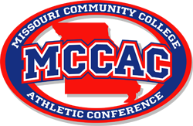
2023-24 All-Conference Men’s Basketball Team
1st Team
Josh Meo – Mineral Area – Player of the Year
Tekao Carpenter – Moberly Area
Amarion Dickerson – Mineral Area
Cliff Barrow – State Fair
Xavier Sykes – Moberly Area
Kyle Germany – West Plains
Caleb Young – Three Rivers
Anthony Sellars – Three Rivers
Jemeal Goines – St. Louis
Akili Evans – Moberly Area

2nd Team
Marcus Watson Jr. – Mineral Area
Freddie Cooper – Moberly Area
Meechie White – Three Rivers
Jaylen Boyd – Jefferson
Devin Davis – St. Louis
Preston Turner – Mineral Area
Isaiah Jackson – State Fair
Jamaray Davenport – St. Louis

Coach of the Year – Pat Smith – Moberly Area

