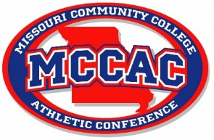
MCCAC WOMEN’S SOCCER ALL-CONFERENCE TEAM 2023
1st Team
Dariyn Hoff | St. Charles
Britini Benedict | St. Charles
Sandra Swartz | St. Charles
Giulia Starman | St. Charles
Jessica Powell | St. Louis
Cierra Bradley | St. Louis
Gracie Eimer | St. Louis
Emilia Wunderlich | Mineral Area
Tash Goodwin | Mineral Area
Emma Cloud | East Central
Rachel Riney | Jefferson
2nd Team
Elin Nilsson | St. Charles
Camdyn Suttory | St. Charles
Paige Richards | St. Charles
Natalia Arevalo | St. Louis
Peyton Lee | St. Louis
Suvada Dubinovic | St. Louis
Lydia Pascoe | Mineral Area
Daisy Brown | Mineral Area
Maria McSherry | East Central
Isabelle Tiepelman | East Central
Sharayah Donovan | Jefferson

Conference Champions: St. Charles Community College
Coach of the Year: Tim Mosby, St. Charles Community College

