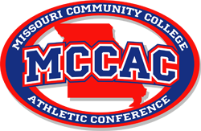
2023 All-Conference Volleyball Teams
First Team All-Conference
- Rosa Brencic, Missouri State University West Plains
- Gibson Beckler, MissouriState University West Plains
- Maja Bochenek, Missouri State University West Plains
- Summer Meyer, Mineral Area College
- Katie Huster, Mineral Are College
- Julia Reis, Jefferson College
- Amari Autman-Branch, Jefferson College
- Abigail Cowell, East Central College
- Isabelle Sapp, St. Louis Community College

Second Team All-Conference
- Caroline Glatkowski, Missouri State University West Plains
- Kyndal Dodd, Mineral Area College
- Payton Roberts, Mineral Area College
- Maju Fernandes, Jefferson College
- Jelena Gray, Jefferson College
- Emma Coburn, East Central College
- Lexi Filkins, East Central College
- Kylee Ball, St. Louis Community College
- Kaylee Gerwitz, St. Louis Community College

2023 Coach of the Year
Paty Figueiredo, Missouri State University West Plains

