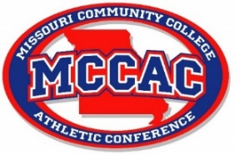
MCCAC MEN’S SOCCER ALL-CONFERENCE TEAM 2023
1st Team
Alex Wilkinson | Mineral Area
Tom Walton | Mineral Area
Jack Taylor | Mineral Area
Josh Wilson | Mineral Area
Matheus Periera | St. Louis
Daniel Dixon | St. Louis
Mathieu Levesque | St. Louis
Jules Denommee | East Central
Ethan Lush | East Central
Sam Hancke | St. Charles
Ignacio Rodriguez | Jefferson
Jervan Matthew | State Fair
2nd Team
Raegan Rintour | Mineral Area
Kyle Nicholls | Mineral Area
Chalon Domian | Mineral Area
Fabricio Roberti | St. Louis
Giuseppe Gereau | St. Louis
Faraj Hussein Shee | St. Louis
Tyler Finder | East Central
Jacob Wipke | East Central
Javier Yniguez | St. Charles
Dayton Strattman | St. Charles
Andres Suarez | Jefferson
Ian Viscarra | State Fair

Conference Champions: Mineral Area College
Coach of the Year: Dan Martin, Mineral Area College

