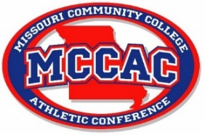
MCCAC MEN’S SOCCER ALL-CONFERENCE TEAM 2022
1st Team
Alvarez Cooper | Jefferson
Charlie Dickerson | Jefferson
Joao Saraiva | Jefferson
Rashaad Ogun | Jefferson
Ben Morlen | St. Charles
Kento Takamura | St. Charles
Michael Quinn | St. Charles
Oliver Green | Mineral Area
Joe Maunsell | Mineral Area
Nicolas Justiniano | St. Louis
Kenzo Florio | State Fair
Miguel Gonzalez | East Central
2nd Team
Charley Leech | Jefferson
Soto Inoue | Jefferson
Ignacio Rodriguez | Jefferson
Lindo Zimba | St. Charles
Grant Birke | St. Charles
Luke Poxon | St. Charles
Alexi George | Mineral Area
Victor Herion | Mineral Area
Breno Zanolla | St. Louis
Matheus Pereira da Silva | St. Louis
Leonardo Camatta | State Fair
Julio Gonzalez | East Central

Conference Champions: Jefferson College
Coach of the Year: Leo Driscoll, Jefferson College

