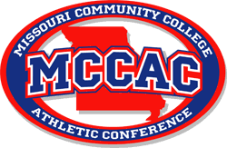
2022 MCCAC Softball All Conference
Morgan Green East Central
Kiersten Nixon Jefferson
Danielle Lindsey Jefferson
Haile Farris Jefferson
Tara Haag Jefferson
Riley Eagan Jefferson
Amber Cage Mineral Area
Haley Mackey State Fair
Alex Gilliland State Fair
Hunter Collins St. Charles
Dayton Kell St. Louis CC
Karlye Happold Three Rivers
Kenlee McAuliffe Three Rivers
Kyla Puckett Three Rivers
Alyson Marcum Three Rivers

Honorable Mention:
Nicole Truitt East Central
Sarah Roth Jefferson
Zoie Hudson Mineral Area
Kelsey Webb State Fair
Rylee Hagens State Fair
Abbey Hultz St. Charles
Mallory Waller St. Charles
Lexi Martinez St. Louis CC
Morgan Shields St. Louis CC
Lexi Sherrick St. Louis CC
Ann Marie Simpson Three Rivers
Helena Garcia Three Rivers

Sportsmanship: State Fair Community College
Coach of the Year: Chris Starkey – Jefferson

