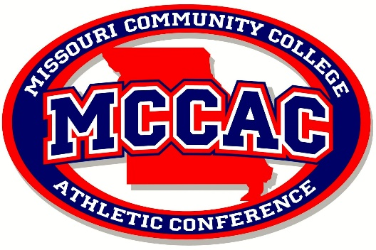

Gene Bess MCCAC Conference Coach of the Year

The Missouri Community College Athletic Conference administrators have announced the creation of the Gene Bess MCCAC Conference Coach of the Year Award in honor of Coach Gene Bess, men’s basketball coach and athletic director who retired from Three Rivers Community College at the conclusion of the 2019-20 academic year. Coach Bess retired as the all-time winningest college basketball coach at any level of college basketball in the United States. Bess was 1,300-416 in 50 seasons at Three Rivers -- 143 more victories than NCAA Division I leader Mike Krzyzewski of Duke. Bess led the Raiders to national titles in 1979 and 1992. During his tenure his players received numerous accolades and his teams won or shared 35 MCCAC Men’s Basketball Championships banners that adorn the newly constructed Three Rivers Rivers Libla Family Sports Complex.
The award will be voted on by the current MCCAC athletic directors and a plaque will be presented to the coach who creates an atmosphere of success with their team combining sportsmanship, academic success and on field/court performance.
------------------------------------------------------------------------------------------------------------------------------------------
MCCAC Gene Bess Conference Coach of the Year Nomination Form

Coaches’ Name__________________________________________
Institution:______________________________________________
Sport:___________________________________________________
Current Year Record/Accomplishments:
____________________________________________________________________________________________________________________________________________________________________________________________________________________________________________________________________________________________________________________________________________________

