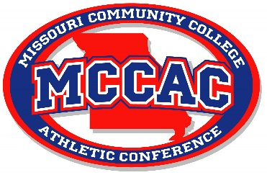
MCCAC Volleyball Sports Code

- NCAA rules, NJCAA guidelines and conference protocol will apply.
- Conference match protocol to be placed at scorer’s table for each match.

Athletic Director Sport Liasion
An MCCAC member institution athletic director will serve as the sport liaison with the duties of providing a conference schedule, receiving nominations for the All-Conference team, determining the conference champion and coach of the year.

Scheduling
Starting in 2015, MCCAC Conference members will play like member division teams twice per year and once against opposite division teams. Matches will count twice for conference standings against opposite division schools. Ex: DI schools on play DI schools twice and DII schools only one time. For conference standings purposes, the one match against DII schools will count double.

Conference games will be played on Wednesday evenings with a 6:30p.m. start time unless coaches agree to change start times or dates.

All –Conference Team Selection
All-Conference selections are to be nominated by each schools’ head coach and sent to the sport liaison AD to be placed on All-Conference Team. The number of athletes from each school is determined by the place finish in the conference. If a co-Championship is awarded, then the teams will receive the same amount of 1st Team and 2nd Team selections.

2015
1st Place Team (3- 1st Team, 1- 2nd Team)
2nd Place Team (2- 1st Team, 2-2nd Team)
3rd Place Team (2- 1st Team, 2- 2nd Team)
4th Place Team (1-1st Team, 2-2nd Team)

2016
1st Place Team (3- 1st Team, 1- 2nd Team)
2nd Place Team (2- 1st Team, 2-2nd Team)
3rd Place Team (2- 1st Team, 2- 2nd Team)
4th Place Team (1-1st Team, 2-2nd Team)
5th Place Team (1-1st team, 1-2nd Team)

Conference Champions
The Conference Championship will be determined by the win/loss record among the member institutions. The opposite division matches will count double in the standings.
Tie Breakers: 1) Head to Head Matches
2) Record vs. Same Division Schools
3) A Co-Champion will be awarded if one champion cannot be determined

Conference Coach of the Year
The coach of the school winning the conference will be Named the MCCAC Coach of the Year.

Scouting Information
Giving scouting information to outside institutions is prohibited.

Sportsmanship
Sportsmanship is strongly encouraged. Understanding the integrity of the
game and promoting that victory has no value if achieved unfairly. (See MCCAC
Sportsmanship Code). A “Team Sportsmanship Award” will given annually.
Coaches will vote at the end of the season.

Respect for opponents, teammates, officials, and spectators should occur at all
times on the court.

All coaches and players will adhere to the “No Tolerance” rule for foul and
abusive language. Offenses will result in a match ejection with a subsequent match
suspension if a red card is issued by an official.

Updated 12/4/2014

