MCCAC MISSION STATEMENT
The Missouri Community College Athletic Conference is made up of member institutions with similar educational missions of supporting and funding intercollegiate athletic programs to enhance the 2-year college experience through physical activity, leadership and sportsmanship.
A. Student athletes are encouraged to attend classes with minimal interruption to their academic schedule.
B. These like-minded institutions are able to receive recognition through conference championships, coach of the year and all-conference awards distributed every season after the conclusion of the conference regular season in their respective conference sponsored sports.

MCCAC Primary Logo- Standards for Use
To promote the association of the MCCAC and its member institutions, it is recommended to use the MCCAC primary logo wherever appropriate. It is important the MCCAC logo is used consistently with the correct PMS colors and size orientation.

When using the primary logo with other graphics, it should have ample clear space or isolation from other elements conflicting with the logo.
3”
2” 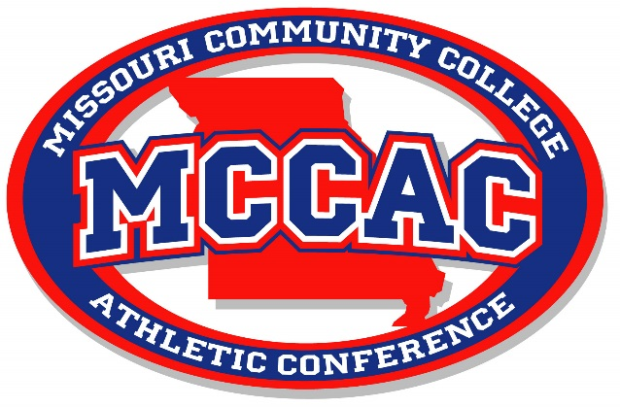
Size: Width: 3 inches Height: 2 inches

PMS Colors
The PMS colors are Red-485 Blue 287 Gray-421
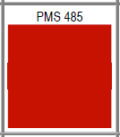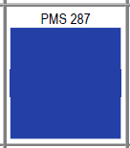

Branding on Uniforms
1. A 3” x 2” patch has been developed to create conference affiliation on uniforms and should be used. The patches are being produced by Unisport for a minimal cost of $1.26 per heat transfer patch. It is recommended the patch be the Pro Sub Twill model which will transfer well and have better flexibility during wear and durability during washing. The 3” x 2” patch is the limit set by the NCAA for uniform apparel conference patches.
Patch Company Contact Information
Uni-Sport, Inc.
Address: 16933 Gramercy Pl
Gardena, CA 90247
Phone: (310) 217-4587
Fax: (310) 329-2364
www.uni-sport.com

Basketball Uniforms
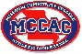
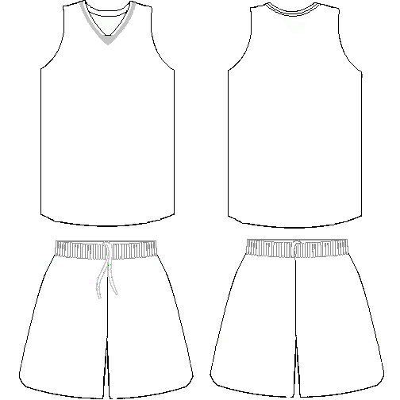

The MCCAC logo should be placed on the upper top corner of either left or right sleeve on short sleeve/capped sleeve jerseys. The logo could also be placed on the shorts on either the left or right leg.

Soccer Uniforms
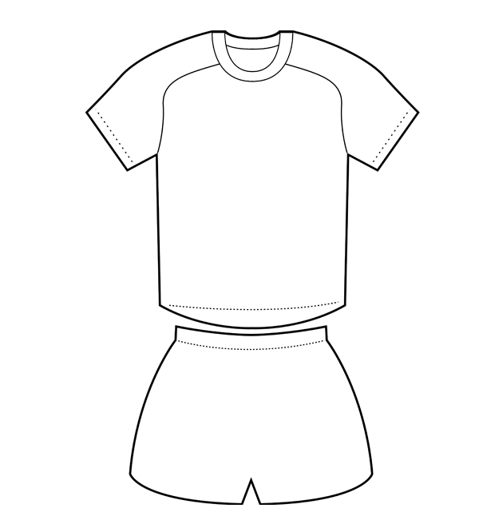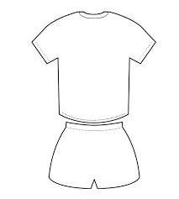
The MCCAC logo should be placed on either left or right shoulder on long sleeve jerseys and short sleeve jerseys. The MCCAC logo could also be on back side under the collar.

Baseball/Softball Uniforms
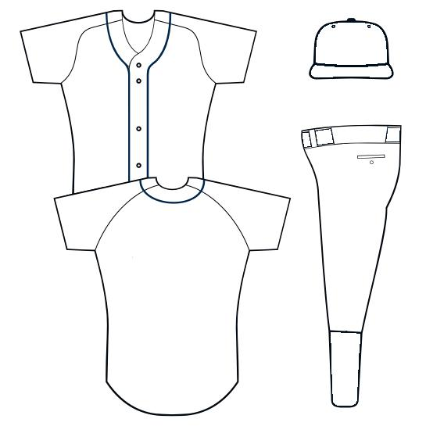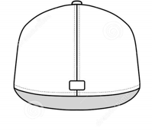

The MCCAC logo should be placed on either left or right shoulder on short sleeve jerseys or the back of the jersey for baseball/softball jerseys. Placement on the hat would be a smaller non-heat transfer embroidery item centered on the back of the hat. This would have to be digitized to meet specifications.

Volleyball Uniforms

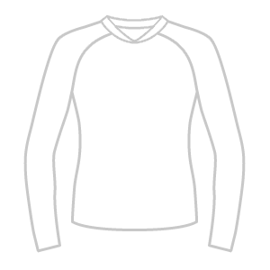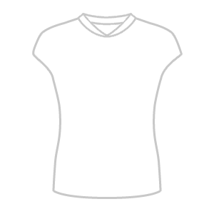

The MCCAC logo should be placed on either left or right shoulder on long sleeve jerseys or on upper top corner of either left or right sleeve on short sleeve/capped sleeve jerseys.

